**OUTPUT**

| **Age** | **Gender** | **Total_Bilirubin** | **Direct_Bilirubin** | **Alkaline_Phosphotase** | **Alamine_Aminotransferase** | **Aspartate_Aminotransferase** | **Total_Protiens** | **Albumin** | **Albumin_and_Globulin_Ratio** | **Dataset** |
| --- | --- | --- | --- | --- | --- | --- | --- | --- | --- | --- |
| **0** | 65 | Female | 0.7 | 0.1 | 187 | 16 | 18 | 6.8 | 3.3 | 0.90 | 1 |
| **1** | 62 | Male | 10.9 | 5.5 | 699 | 64 | 100 | 7.5 | 3.2 | 0.74 | 1 |
| **2** | 62 | Male | 7.3 | 4.1 | 490 | 60 | 68 | 7.0 | 3.3 | 0.89 | 1 |
| **3** | 58 | Male | 1.0 | 0.4 | 182 | 14 | 20 | 6.8 | 3.4 | 1.00 | 1 |
| **4** | 72 | Male | 3.9 | 2.0 | 195 | 27 | 59 | 7.3 | 2.4 | 0.40 | 1 |

<class 'pandas.core.frame.DataFrame'>

RangeIndex: 583 entries, 0 to 582

Data columns (total 11 columns):

# Column Non-Null Count Dtype

--- ------ -------------- -----

0 Age 583 non-null int64

1 Gender 583 non-null object

2 Total_Bilirubin 583 non-null float64

3 Direct_Bilirubin 583 non-null float64

4 Alkaline_Phosphotase 583 non-null int64

5 Alamine_Aminotransferase 583 non-null int64

6 Aspartate_Aminotransferase 583 non-null int64

7 Total_Protiens 583 non-null float64

8 Albumin 583 non-null float64

9 Albumin_and_Globulin_Ratio 579 non-null float64

10 Dataset 583 non-null int64

dtypes: float64(5), int64(5), object(1)

memory usage: 50.2+ KB

Age False

Gender False

Total_Bilirubin False

Direct_Bilirubin False

Alkaline_Phosphotase False

Alamine_Aminotransferase False

Aspartate_Aminotransferase False

Total_Protiens False

Albumin False

Albumin_and_Globulin_Ratio True

Dataset False

dtype: bool

Age 0

Gender 0

Total_Bilirubin 0

Direct_Bilirubin 0

Alkaline_Phosphotase 0

Alamine_Aminotransferase 0

Aspartate_Aminotransferase 0

Total_Protiens 0

Albumin 0

Albumin_and_Globulin_Ratio 4

Dataset 0

dtype: int64

0 0.90

1 0.74

2 0.89

3 1.00

4 0.40

...

578 0.37

579 1.10

580 1.00

581 1.00

582 1.50

Name: Albumin_and_Globulin_Ratio, Length: 583, dtype: float64

|  | **Age** | **Gender** | **Total_Bilirubin** | **Direct_Bilirubin** | **Alkaline_Phosphotase** | **Alamine_Aminotransferase** | **Aspartate_Aminotransferase** | **Total_Protiens** | **Albumin** | **Albumin_and_Globulin_Ratio** | **Dataset** |
| --- | --- | --- | --- | --- | --- | --- | --- | --- | --- | --- | --- |
| **count** | 583.000000 | 583.000000 | 583.000000 | 583.000000 | 583.000000 | 583.000000 | 583.000000 | 583.000000 | 583.000000 | 583.000000 | 583.000000 |
| **mean** | 44.746141 | 0.756432 | 3.298799 | 1.486106 | 290.576329 | 80.713551 | 109.910806 | 6.483190 | 3.141852 | 0.947427 | 1.286449 |
| **std** | 16.189833 | 0.429603 | 6.209522 | 2.808498 | 242.937989 | 182.620356 | 288.918529 | 1.085451 | 0.795519 | 0.318522 | 0.452490 |
| **min** | 4.000000 | 0.000000 | 0.400000 | 0.100000 | 63.000000 | 10.000000 | 10.000000 | 2.700000 | 0.900000 | 0.300000 | 1.000000 |
| **25%** | 33.000000 | 1.000000 | 0.800000 | 0.200000 | 175.500000 | 23.000000 | 25.000000 | 5.800000 | 2.600000 | 0.700000 | 1.000000 |
| **50%** | 45.000000 | 1.000000 | 1.000000 | 0.300000 | 208.000000 | 35.000000 | 42.000000 | 6.600000 | 3.100000 | 0.950000 | 1.000000 |
| **75%** | 58.000000 | 1.000000 | 2.600000 | 1.300000 | 298.000000 | 60.500000 | 87.000000 | 7.200000 | 3.800000 | 1.100000 | 2.000000 |
| **max** | 90.000000 | 1.000000 | 75.000000 | 19.700000 | 2110.000000 | 2000.000000 | 4929.000000 | 9.600000 | 5.500000 | 2.800000 | 2.000000 |

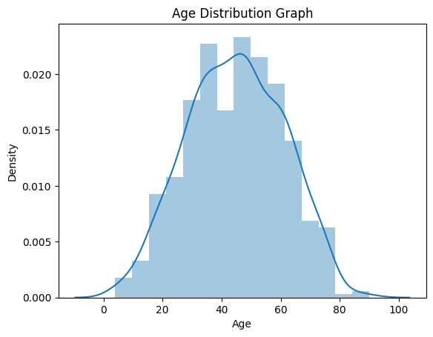

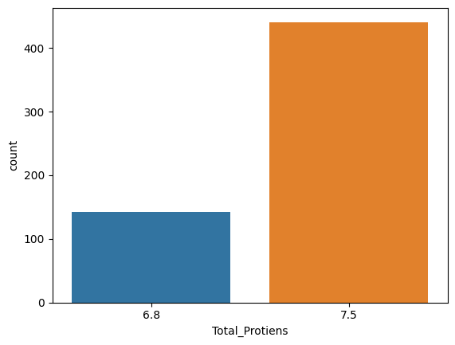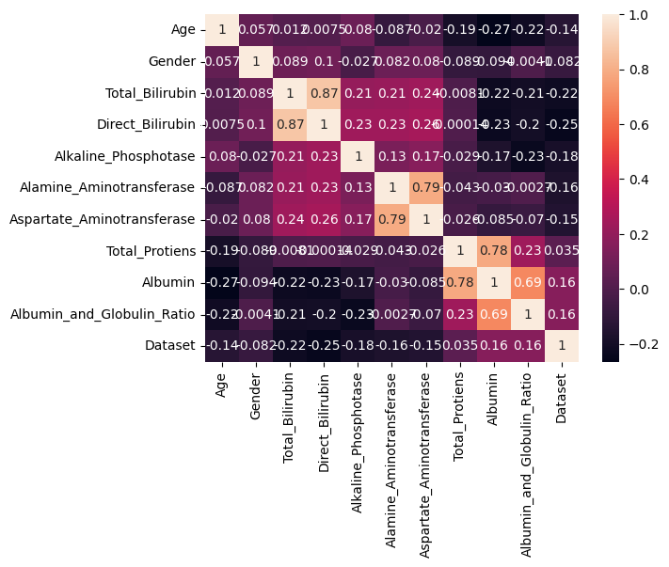

|  | **Age** | **Gender** | **Total_Bilirubin** | **Direct_Bilirubin** | **Alkaline_Phosphotase** | **Alamine_Aminotransferase** | **Aspartate_Aminotransferase** | **Total_Protiens** | **Albumin** | **Albumin_and_Globulin_Ratio** | **Dataset** |
| --- | --- | --- | --- | --- | --- | --- | --- | --- | --- | --- | --- |
| **0** | 1.252098 | -1.762281 | -0.418878 | -0.493964 | -0.426715 | -0.354665 | -0.318393 | 0.292120 | 0.198969 | -0.149025 | -0.633595 |
| **1** | 1.066637 | 0.567446 | 1.225171 | 1.430423 | 1.682629 | -0.091599 | -0.034333 | 0.937566 | 0.073157 | -0.651777 | -0.633595 |
| **2** | 1.066637 | 0.567446 | 0.644919 | 0.931508 | 0.821588 | -0.113522 | -0.145186 | 0.476533 | 0.198969 | -0.180447 | -0.633595 |
| **3** | 0.819356 | 0.567446 | -0.370523 | -0.387054 | -0.447314 | -0.365626 | -0.311465 | 0.292120 | 0.324781 | 0.165194 | -0.633595 |
| **4** | 1.684839 | 0.567446 | 0.096902 | 0.183135 | -0.393756 | -0.294379 | -0.176363 | 0.753153 | -0.933340 | -1.720124 | -0.633595 |

Looking in indexes: <https://pypi.org/simple>, <https://us-python.pkg.dev/colab-wheels/public/simple/>

Collecting imblearn

Downloading imblearn-0.0-py2.py3-none-any.whl (1.9 kB)

Requirement already satisfied: imbalanced-learn in /usr/local/lib/python3.9/dist-packages (from imblearn) (0.10.1)

Requirement already satisfied: joblib>=1.1.1 in /usr/local/lib/python3.9/dist-packages (from imbalanced-learn->imblearn) (1.2.0)

Requirement already satisfied: numpy>=1.17.3 in /usr/local/lib/python3.9/dist-packages (from imbalanced-learn->imblearn) (1.22.4)

Requirement already satisfied: scikit-learn>=1.0.2 in /usr/local/lib/python3.9/dist-packages (from imbalanced-learn->imblearn) (1.2.2)

Requirement already satisfied: scipy>=1.3.2 in /usr/local/lib/python3.9/dist-packages (from imbalanced-learn->imblearn) (1.10.1)

Requirement already satisfied: threadpoolctl>=2.0.0 in /usr/local/lib/python3.9/dist-packages (from imbalanced-learn->imblearn) (3.1.0)

Installing collected packages: imblearn

Successfully installed imblearn-0.0

1 329

2 137

Name: Dataset, dtype: int64

1 329

2 329

Name: Dataset, dtype: int64

precision recall f1-score support

1 1.00 1.00 1.00 87

2 1.00 1.00 1.00 30

accuracy 1.00 117

macro avg 1.00 1.00 1.00 117

weighted avg 1.00 1.00 1.00 117

|  | **Classification models** | **accuracy_score** |
| --- | --- | --- |
| **0** | RandomForestClassifier | 1.0 |

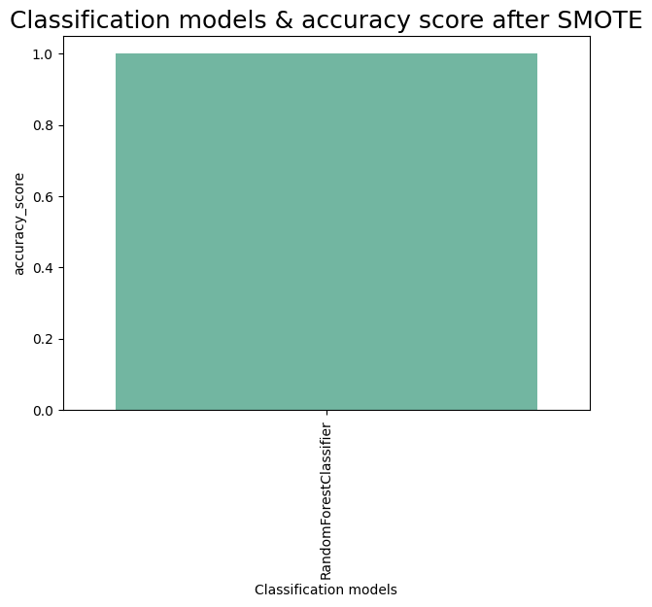

ExtraTreesClassifier

ExtraTreesClassifier()

array([0.11777117, 0.02645932, 0.11215644, 0.103584 , 0.11695258,

0.11107897, 0.11545029, 0.09372862, 0.10488599, 0.09793263])

|  | **0** |
| --- | --- |
| **Age** | 0.117771 |
| **Alkaline_Phosphotase** | 0.116953 |
| **Aspartate_Aminotransferase** | 0.115450 |
| **Total_Bilirubin** | 0.112156 |
| **Alamine_Aminotransferase** | 0.111079 |
| **Albumin** | 0.104886 |
| **Direct_Bilirubin** | 0.103584 |
| **Albumin_and_Globulin_Ratio** | 0.097933 |
| **Total_Protiens** | 0.093729 |
| **Gender** | 0.026459 |

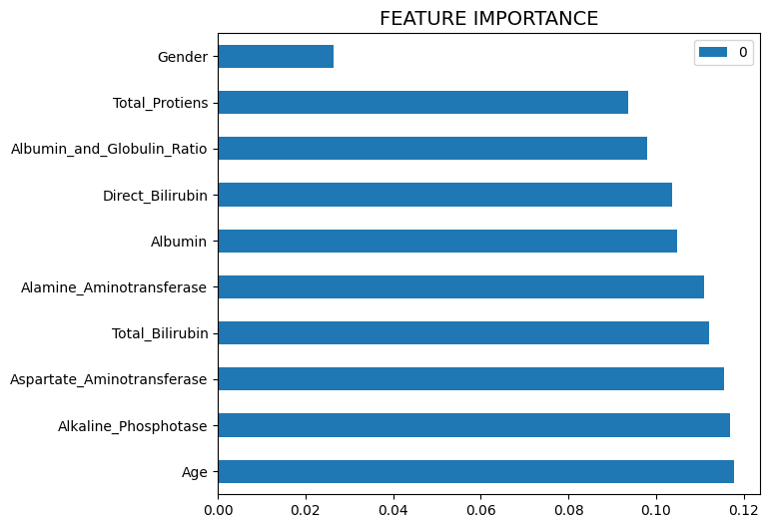

['ETC.pk1'

